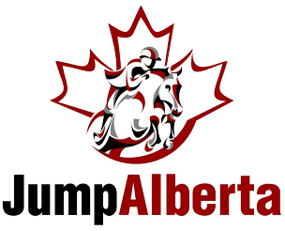

Dear Jump Alberta Members,
In an effort to continue to support the development and recognition of our members, we have refined the divisions that will receive points throughout the year and receive recognition at our year end gala. We are excited for the 2020 show season and cannot wait to host our first Year End Awards Gala in Edmonton on January 9, 2021.

JUMPERS

Pony Jumper

0.70m/0.75m Jr/Am Jumper
0.70m/0.75m Jr/Am Jumper Medal

0.80m/0.85m Jr/Am Jumper

0.90m Jr/Am Jumper
0.90m Jr/Am Jumper Medal

1.00m Jr/Am Jumper
Greenhawk Calgary 1.00m Jr/Am Jumper Medal

1.10m Jr/Am Jumper

1.15m Jr/Am Jumper

1.20m Jr/Am Jumper

4 Year Old Young Horse
5 Year Old Young Horse
6 Year Old Young Horse
7 Year Old Young Horse

HUNTERS

Junior “C” Flat and Over Fences
Junior “B” Flat and Over Fences
Junior “A” Flat and Over Fences

Childrens Hunter
Childrens EQ
Greenhawk Calgary Childrens Hunter Medal

Junior/Amateur Owner Hunter

Adult Hunter
Adult Eq 3’
Greenhawk Calgary Adult Hunter Medal

Modified Jr/Am Hunter
Modified Jr/Am Eq
Greenhawk Calgary Jr/Am Hunter Medal 3’3”

Baby Green Hunter
Pre Green Hunter
Combined Hunter
Hunter Derby
Greenhawk Classic Series

Pony Hunter
Pony Eq
Greenhawk Calgary Pony Hunter Medal

x-Rail Hunter
X-rail Eq

2’0” Hunter
2’0” Eq

Short Stirrup Pony & Short/Long Stirrup Hunter
Short/Long Stirrup Eq
Short/Long Stirrup Hunter Medal

Pre Child/Adult Hunter
Pre Child/Adult EQ
Pre Child/Adult Hunter Medal 2’6”

Modified Child/Adult Hunter (2’9”)
Modified Child/Adult Eq
Modified Child/Adult Hunter Medal 2’9”

